1 2 3 4 5 6 7 8

Section B-B (1:4) B
A

_{B} 6mm [.24in] B

20mm [.79in]
C
14mm [.55in]

A A

D

A

B
C
C

C

D

Section C-C (1:1)
6mm [.24in]

E

Drawer Fronts:
25mm [1in]
19mm [.75in]

Section A-A (1:4)

Dept. Technical reference
135°

Created by
E

Mullion Details
Approved by

Drawer profile to match door profile

Mullion Details:
Available in 1, 3, 4 and 6 lites as standard offering.
Sales
N/A
Engineering
Document type
Sales Blueprint
Title
11/4/2021
Sales
Document status
Released
DWG No.
12/1/2021

^{F} Other customizations availabe to request

NORTE - RIO
NORTE - 016 F

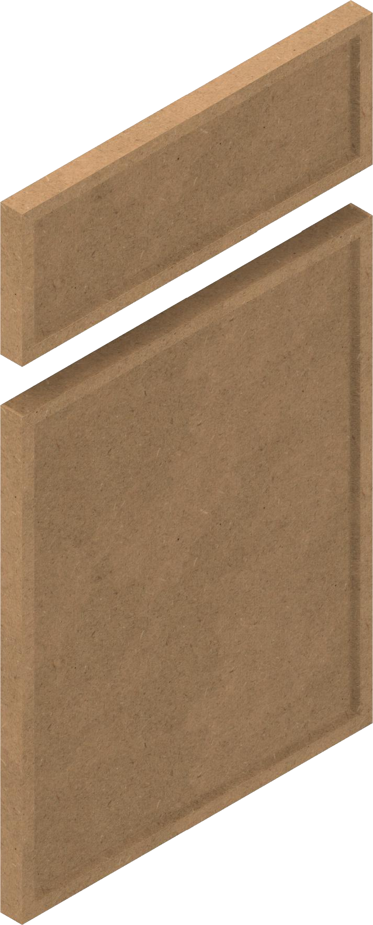

Rev. Date of issue Sheet
A 1/3/2022 1/1
1 2 3 4 5 6 7 8

