1 2 3 4 5 6 7 8

A Section B-B (1:4) B A

_{B} 11.6mm B B

C

C
75mm [2.95in]
^{C} 55mm [2.17in] C

A A
28mm [1.1in]

- D

Section C-C (1:1)
28mm [1.1in]

Drawer Fronts:
Drawer fronts will have a minimum of 50mm (1-15/16”) center flat panel.

- Drawer fronts less than 200mm (7-7/8”) may have reduced rails and a 1-piece door design (pocketed center flat panel).
19mm [.75in]
6mm [.25in]

20°

Section A-A (1:4)

Dept. Technical reference Created by

E

Mullion Details
Approved by

Drawer fronts less than 150mm (5-15/16") overall will be slabs with no center flat panel.

Mullion Details:
Sales
N/A
Engineering
Document type
Sales Blueprint
Title
11/4/2021
Sales
Document status
Released
DWG No.
12/1/2021

- Available in 1, 3, 4 and 6 lites as standard offering.
Other customizations availabe to request

NORTE - BARCA
NORTE - 001 F
Rev. Date of issue Sheet

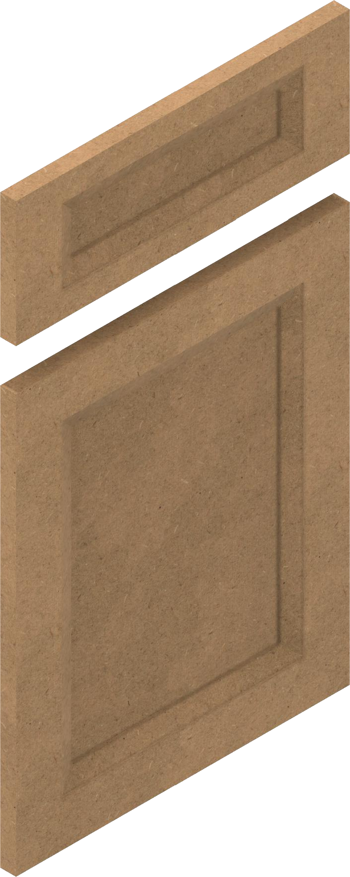
1 2 3 4

5 6 7
A 1/3/2022
1/1
8

